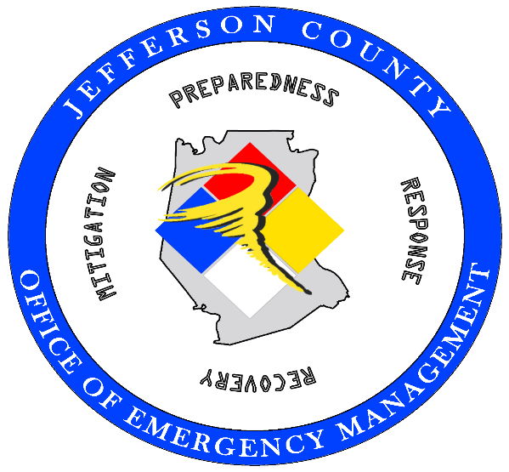

A Local Guide to Disasters

______________________________________________________________

Before, During

and After

TABLE OF CONTENTS

Disaster Preparedness …………………………………………………………… 2
Personal Log of Important Information …………………………………………. 3
Local Disaster Assistance ……………………………………………………….. 4
Federal Disaster Declaration Process …………………………………………… 5
Declared Federal Disaster Assistance Information ……………………………... 6

1

DISASTER PREPAREDNESS

Be prepared for disasters on a personal level, make a kit, stay informed and take steps to insure you and your family are as prepared as possible before a disaster strikes. Information on making an emergency preparedness kit can be found by visiting www.health.mo.gov/emergencies/readyin3 or www.ready.gov
Important documents should be included in your disaster kit so you are able to locate them easily in order to apply for disaster aid.
DISASTER DOCUMENTS CHECKLIST
Items to include;
- Identification: Driver’s license, passport, photo ID, green card, visa, etc.

- Belongings: A written inventory of your belongings, backed up by “date stamped” photos and/or a video of all areas of your home and property, inside, outside and out-buildings before the disaster, this can help prove what you have lost and what has been damaged.

- Medical: Make a list of medications and doctor contacts for yourself, family members and pets, include prescription bottles, inhalers, oxygen, immunization records, blood type cards, eyeglasses, include your pet’s records such as immunization record, prescriptions and photos for identification, etc.

- Proof of Address: Copies of recent utility bills, deed, lease agreement in order to prove your address so you can apply for benefits and/or return to your home if the disaster area is secured by law enforcement.

- Insurance: Life, medical, Medicaid, Medicare, vehicle, homeowners and other property insurance policies.

- Legal documents: Birth Certificates, adoption papers, child custody documents, orders of protection, divorce decrees, wills, powers of attorney, etc.

- Cash and banking items: Cash in the event ATM and electronic transfers are not available due to power outages, credit card and debit/ATM card information, check books, banking books, account documents, deeds and leases, mortgage and other loan documents.

- Cell phones and chargers, this may be the only way you are able to apply available for assistance.

- Other important items: Recent pay stub, Social Security card, Veteran’s or Military ID, food stamp and other benefit eligibility documents, etc., a list of your bills with account numbers and mailing addresses for each.

2
Loans and credit cards Account number Customer service number
Mortgage
Home equity loan
Car loan
Credit card
Student loan
Other:

Home and Utilities Account number Customer service number
Rent
Cable or satellite
Water
Electricity
Phone
Other:

Other Accounts and Insurance Account number Customer service number
Homeowners or renters Insurance
Auto insurance
Medical insurance
Checking account
Savings account
Investment account

3

LOCAL DISASTER ASSISTANCE

After a disaster occurs, emergency assistance such as food, shelter, clothing and medical needs may be available to disaster survivors. These services are primarily administered by voluntary organizations, faith-based organizations and community organizations.
First steps:
- Take photos of damaged areas of your home before cleaning, documentation is a vital step in the recovery process.
- Contact your insurance carrier to file a claim for disaster related damages.
- Save all receipts for disaster related purchases.
- Keep abreast of your local Emergency Management Agency’s information and directions bit.ly/oemjeffco
At this initial period of the disaster your Local Emergency Management Office will be working to provide information to local authorities and working with local voluntary organizations to provide as much assistance as is available.
Get Connected with Local Community Services –
- Resources.redcross.org
- Find additional help and report damages https://mo211.myresourcedirectory.com/ or Dial 2-1-1 (or 1-800-427-4626) TTY (1-866-385-6525)
- Access local Jefferson County list of Community Services www.join-n.org
Keep abreast of your local Emergency Management Agency’s information and directions bit.ly/oemjeffco

4

FEDERAL DISASTER DECLARATION PROCESS
Following a significant weather event that may be beyond the capabilities of local, state and volunteer organizations, the federal government has established a standardized procedure based on statewide damages to seek a Federal Major Disaster Declaration.
Here is how that process generally works:
Incident Occurs
When a severe weather event, flooding, tornado, earthquake, or some other large event occurs, it can lead to overwhelming damage and high emergency response and recovery costs. Local governments may not be able to meet the need and may seek state assistance in responding and recovering from the emergency. The local government may declare a “local disaster declaration” enabling them to request assistance from the State.

State of Emergency Declaration
Based on local requests for assistance or the likelihood that such requests will be forthcoming, the Governor may issue an Executive Order declaring a “State of Emergency”. The State of Emergency declaration allows state agencies to provide direct assistance to local governments. “The State of Emergency” declaration is also required if the Governor later seeks a federal Major Disaster Declaration from the President.

Local Damage Assessments
In anticipation of potentially seeking federal assistance, local governments (generally at the county level) survey damage and tally the estimated damage.

Joint Damage Assessments
When a county’s own damage assessments indicate there is damage significant enough for the county to likely qualify for federal assistance, the county can request Joint Damage Assessments. Joint Damage Assessments are conducted by local, state and federal teams (local emergency management officials, State Emergency Management Agency, Federal Emergency Management Agency and the U.S. Small Business Administration) working in unison. The teams jointly view, review and document the damage.

Requesting a Federal Major Disaster Declaration
Once the State tallies the damage assessment totals for all the counties affected by the disaster event, and if together they meet FEMA’s damage and emergency response cost threshold for the state of Missouri, the Governor can request a federal “Major Disaster Declaration” from the President.

FEMA Review and Recommendation
The regional office reviews the Governor’s request, makes a recommendation, and submits the request to FEMA headquarters and the U.S. Department of Homeland Security in Washington, D.C.

Presidential Determination
Following all reviews and recommendations, the President makes the decision on the Governor’s request for a federal “Major Disaster Declaration”. This is why the declaration is sometimes called a "Presidential Disaster Declaration."
5
DECLARED FEDERAL DISASTER ASSISTANCE INFORMATION

Once the President declares a “Presidential Disaster Declaration” federal assistance is made available to supplement local government and voluntary relief organizations pursuant to the Robert T. Stafford Disaster Relief and Emergency Assistance Act, (the Stafford Act).
There are two disaster declarations that FEMA may make, each are based on local and state damage thresholds.
- Public Assistance declaration – (PA) – assists jurisdictions in the repair of infrastructure and public works (i.e. roads, bridges, etc.)
- Individual Assistance declaration – (IA) – Assistance to individuals, families and businesses in a disaster affected area if a disaster declaration is made. This federal assistance is generally provides funding to make your home safe, sanitary and functional.
It is important to understand that not everyone who has been affected by a disaster will be eligible to receive federal disaster assistance.
Two good resources in helping to understand the FEMA Process:
- FEMA Applicant Guide, “Help After a Disaster: Applicant’s Guide to Individuals and Households Program”. You will be mailed a copy after registering with FEMA, or you can read a copy online at http://www.fema.gov/help-after-disater.
- The Missouri Legal Services Disaster Manual, https://www.lsmo.org/node/68/recovering-natural-disaster-missouri-disaster-manual
Once a disaster has been declared by FEMA, it is essential to register with FEMA to ensure access to all available assistance. You may register with FEMA by calling the FEMA Helpline at 1-800-621-3362 (TTY: 1-800-462-7585) or by visiting http://www.fema.gov
Have the following on hand when calling:
- Social Security Number
- Pre-Disaster address
- Current Address
- Phone number where you can be reached
- Insurance information
- Total household annual income
- Description of losses caused by the disaster
Keep abreast of your local Emergency Management Directions bit.ly/oemjeffco

6

Red Cross Resources by Zip-Code
Resources.redcross.org

Salvation Army Services
https://www.salvationarmyusa.org/usn/plugins/gdosCenterSearch?mode=query_2&lat=38.43&lng=-90.39&code=US&query=63010&category=7

Veterans
https://www.hudexchange.info/homelessness-assistance/resources-for-homeless-veterans/

FEMA Disaster Assistance Application (Once the FEMA Individual Assistance Declaration is made available)
https://www.disasterassistance.gov/

7

